# Exercises: Introduction to Databases by using MySQL Workbench

This document defines the **exercise assignments** for the ["Databases Basics - MySQL" course @ Software University.](https://softuni.bg/trainings/1443/databases-basics-mysql-september-2016)

**MySQL Workbench Prerequisites**

**To be able to install and run MySQL Workbench 6.3 your System needs to have libraries listed below installed. The listed items are provided as links to the corresponding download pages where you can fetch the necessary files.**

[**Microsoft .NET Framework 4.5**](https://www.microsoft.com/en-us/download/details.aspx?id=30653)

[**Visual C++ Redistributable for Visual Studio 2015**](https://www.microsoft.com/en-us/download/details.aspx?id=48145)

**Download and install required packages.**

## Download and Install MySQL Community Server + MySQL Workbench

Download and install MySQL Community Server. Do not install unneeded features of MySQL Community Server.

### Task 1. Download MySQL Community Server

Go to the MySQL web site and download MySQL Community Server <http://dev.mysql.com/downloads/mysql/>

### Task 2. Install the MySQL Community Server + Workbench

1. Open installation file and choose the **Setup type** to be **Custom**. Then click **Next.**

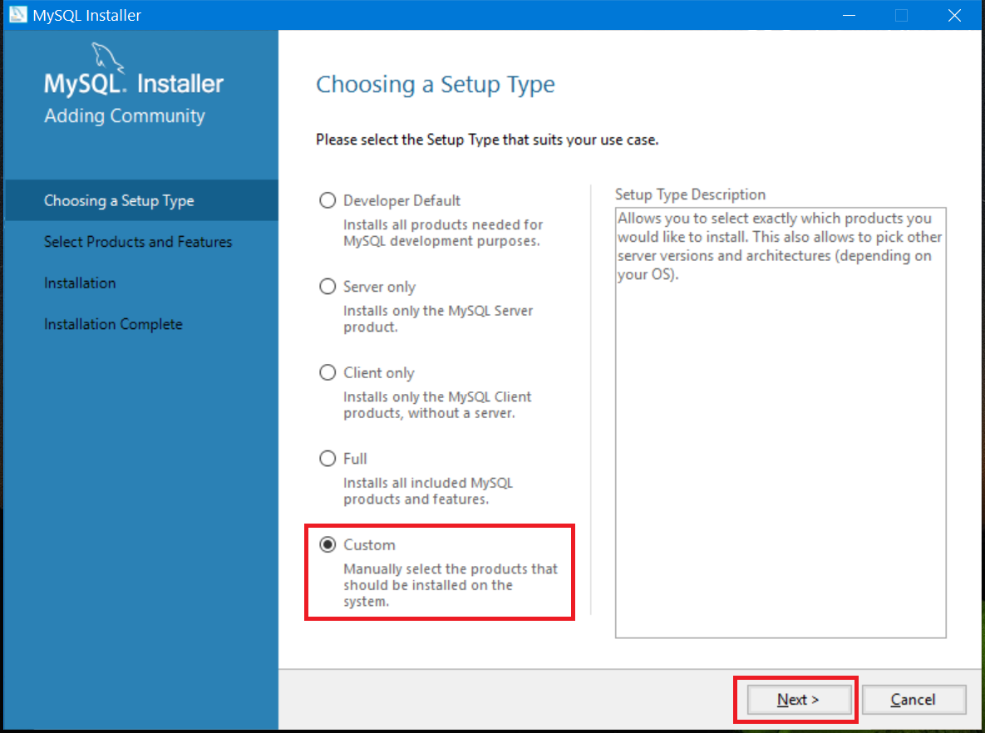

1. All the features we need are **MySQL Server**, **MySQL Workbench, Connector/J**, **Connector/NET and MySQL Workbench**. All other features are optional and won’t be needed for that course.

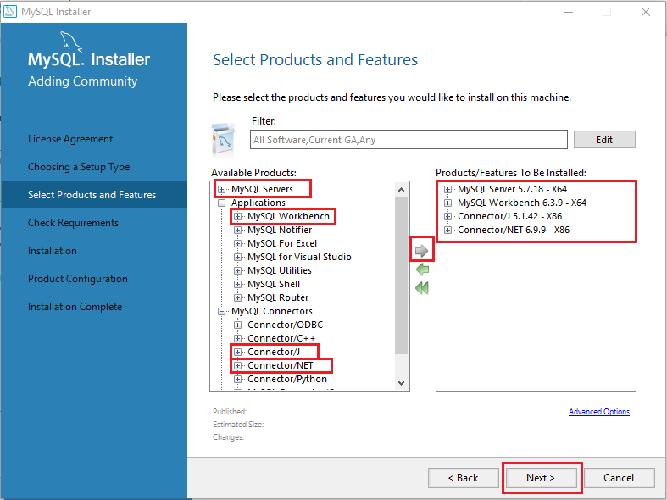

1. Just click **Execute** and the setup will install these features

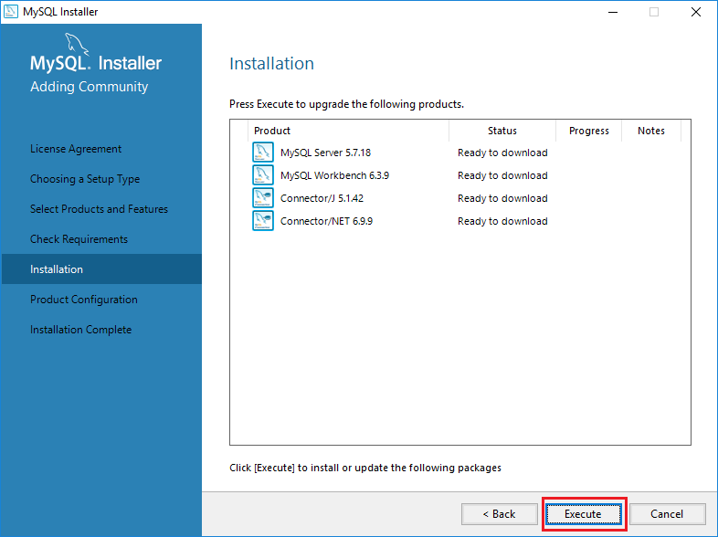

1. Choose the configuration type to be a **Development Machine** and click on Next.

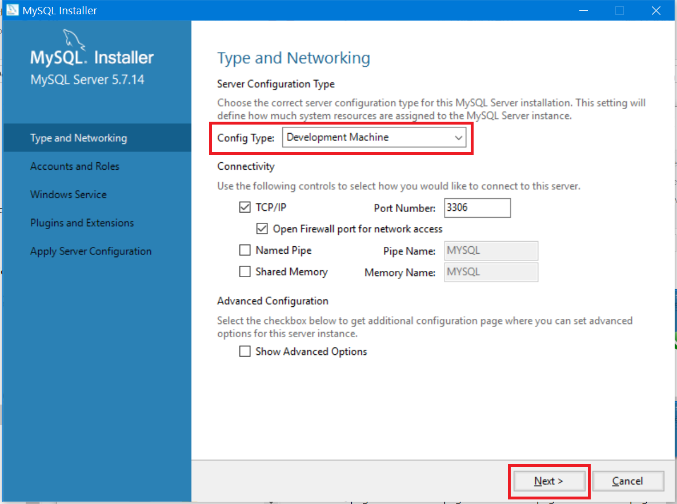

1. Set password to the Root account.

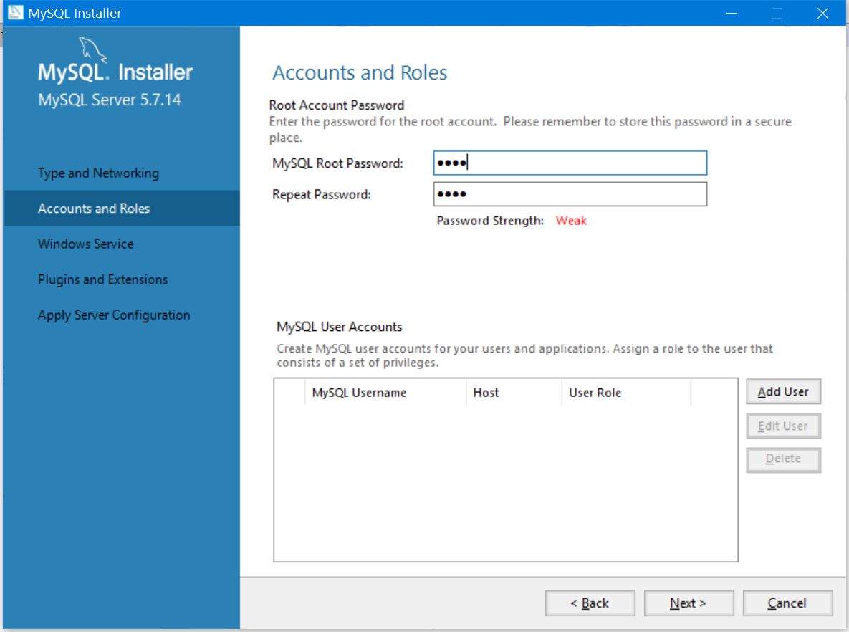

1. Here you can set the **MySQL Server** to run as **Windows Service** and to start automatically at Windows start up. This is the recommended way. Otherwise you must start up MySQL every time before working with the database.

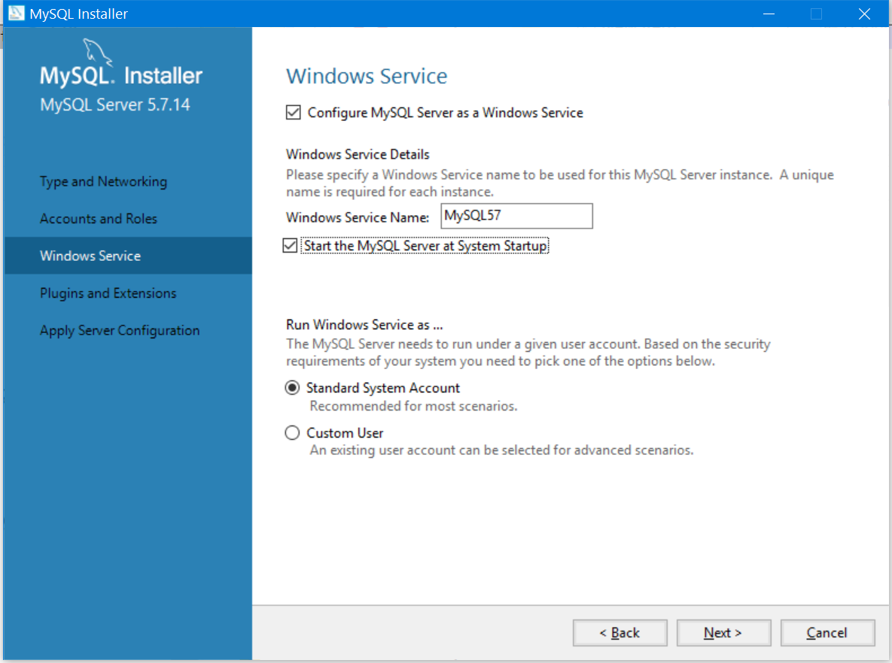

1. Click **Next >** to start the installation and wait until it finishes installing

## Problem 2. Create New Database

1. First you need to create a new Connection. Click on Plus (+) icon.

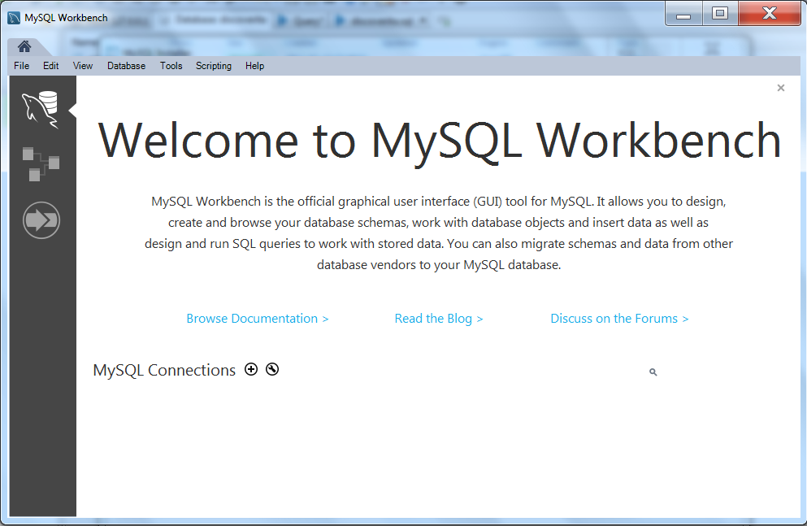

1. Provide a connection name. Leave all other values with their default values. Click OK.

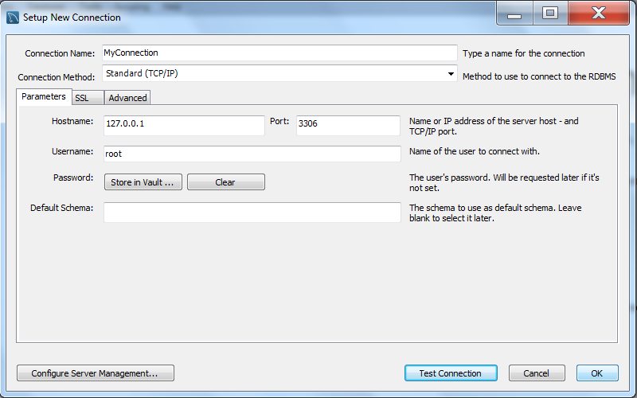

1. Click your connection. In case you have set a password for the root user (when you installed MySQL sever), you will be asked to insert this password. **Your MySQL Server should be started** **for MySQL Workbench to be able to connect.**

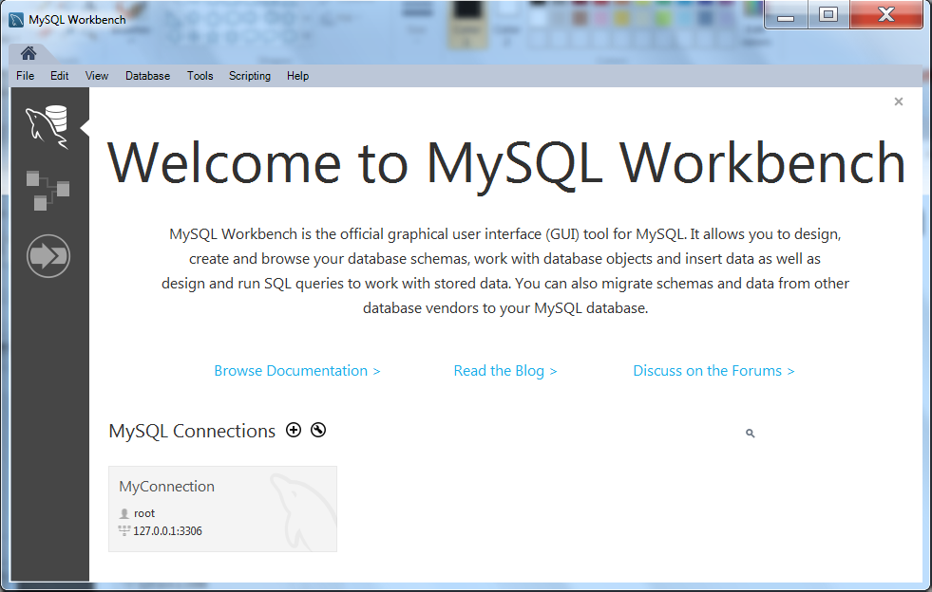

1. Right click on blank space in SHEMAS area on the left. Choose “Create Schema…” item.

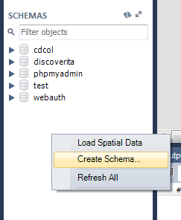

1. Provide schema name. Click Apply.

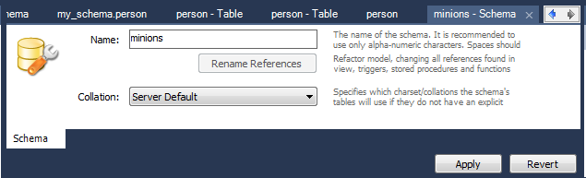

1. Review generated SQL script for schema creation. Click Apply to execute script and create your new database.

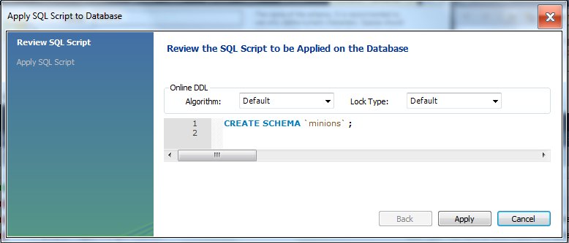

## Problem 3. Create Table

1. Double click on “minions” schema. Right click over Tables, choose “Create Table…” option.

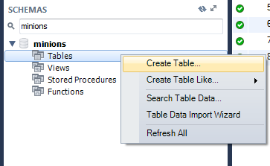

1. Provide Table name. Create columns **id, name, age**. Id and name are **required**; Age should **allow null values**. Set the **id** as **primary key**. Click Apply.

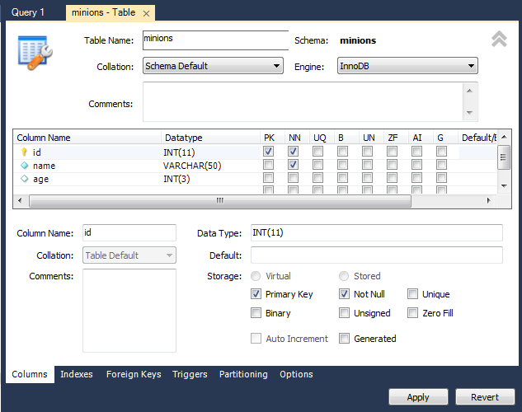

## Problem 4. Insert Data in the Table

1. Select data from table

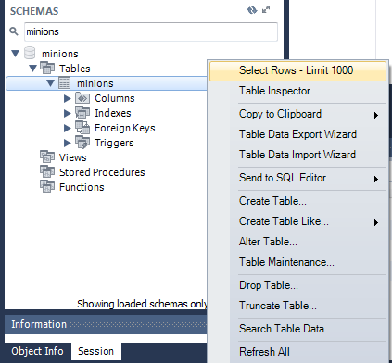

1. Insert data in the table as it’s shown on the picture, by directly editing table cells. **Click Apply.**

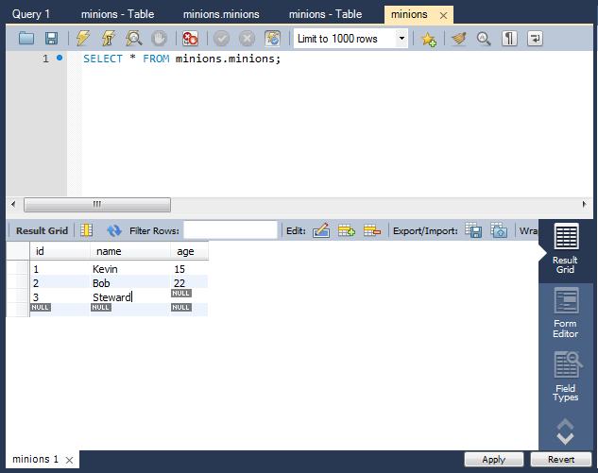

## Update One Record

Change **Steward’s age** from **NULL** to **10**

## Update All Records

Increase all of the **Minions’** **age** with 1 years.

## Delete Record

In the Result Grid for the table, **right click** on the row where **Bob** is situated and delete it. **Click Apply.**

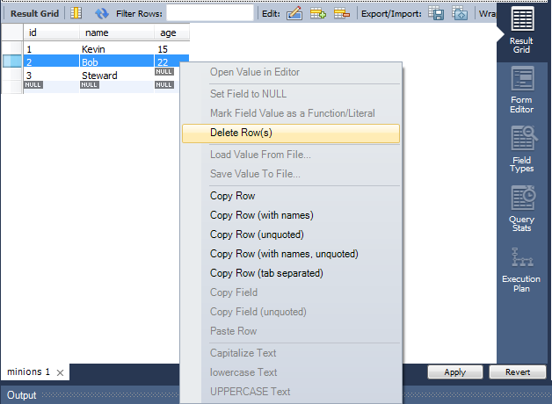

## Create New Table

Create new table **towns**. Every town has **id (int)** and **name (text)**. Make the **id** column **primary key**.

## **Connect Tables

Now let’s make a connection (or relationship) between our two tables. First we need modify our minions table. Add column **town_id** in it **(IMPORTANT: The type of the column must be the same as the type of the column id of the towns table)**.

### Hint

1. **Right click** on **minions** table and choose “Alter Table…” item.

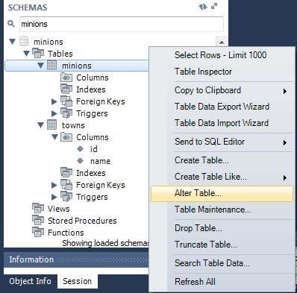

1. Add **town_id** column **of type int(11).** Go to “**Foreign keys**” tab. Insert values as you see on the picture**. Click Apply.**

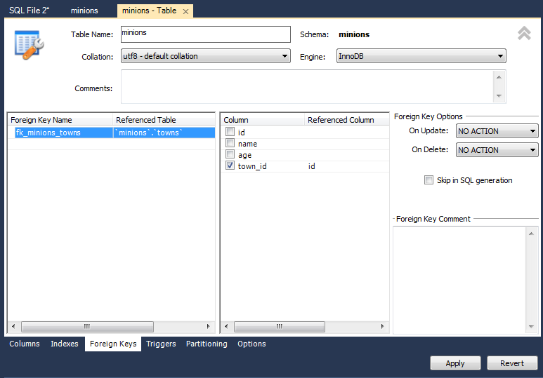

## Create New Database

Now on your own create a new database **school**. Add a few tables to the database: **students (id, name, age, phone_number)**, **classes (id, name, max_students), teachers(id, name, class)**. Add columns for the tables. Populate the tables with random content. Then delete and make changes in some records.

## *Generate SQL Script

Generate SQL script from the **school** database. View the script file and try to understand different commands. Execute the script.